**Asset Management: Homework 5**

**Yuyuan Cui**

**New York Campus**

**ID: yuyuanc**

**1. Performance Evaluation**

**1. a**

Choose Hedge Fund Index 6, 16, 26, 36, 29

|  |  |  |  |  |
| --- | --- | --- | --- | --- |
| **Index 6, Coefficient Estimate** | Sub Period 1 | Sub Period 2 | Sub Period 3 | Sub Period 4 |
| Alpha | 0.008156102 | 0.015509677 | 0.012639602 | -0.003341452 |
| SP500 | 0.0912344538 | -0.0496246096 | 0.0911549446 | 0.0809225239 |
| USD | -0.0734365908 | -0.0598429720 | 0.0021981711 | -0.0099754472 |
| BOND | -0.0632854779 | 0.1545494983 | 0.1326470582 | 0.0094544284 |
| CREDIT | 0.0010659353 | -0.0007724099 | -0.0034581061 | 0.0019331870 |
| DVIX | -0.0008046172 | -0.0009890376 | -0.0004431928 | -0.0002025983 |

|  |  |  |  |  |
| --- | --- | --- | --- | --- |
| Index 6, Coefficient Standard Error | Sub Period 1 | Sub Period 2 | Sub Period 3 | Sub Period 4 |
| Alpha | 0.007100650 | 0.015978132 | 0.003207657 | 0.002571015 |
| SP500 | 0.0381100283 | 0.0497966257 | 0.0353983299 | 0.0179084175 |
| USD | 0.0479942763 | 0.0788949688 | 0.0339871847 | 0.0262262301 |
| BOND | 0.0801882398 | 0.1983351279 | 0.0655862765 | 0.0424157711 |
| CREDIT | 0.0039917265 | 0.0073115352 | 0.0012420040 | 0.0007671162 |
| DVIX | 0.0003602285 | 0.0005762366 | 0.0003414152 | 0.0001755582 |

|  |  |  |  |  |
| --- | --- | --- | --- | --- |
| **Index 16, Coefficient Estimate** | Sub Period 1 | Sub Period 2 | Sub Period 3 | Sub Period 4 |
| Alpha | 0.09694452 | -0.29763720 | 0.03694936 | 0.01037659 |
| SP500 | -1.2448031612 | -0.490709243 | -1.160599083 | -0.7158058243 |
| USD | -0.0445753813 | 0.627671357 | -0.059791554 | -0.0979337406 |
| BOND | 1.0206559710 | -0.786204447 | -0.002444692 | 0.1425772787 |
| CREDIT | -0.0491207786 | 0.124057478 | -0.012393252 | -0.0048292979 |
| DVIX | -0.0006418458 | 0.005833013 | -0.001855986 | -0.0006751673 |

|  |  |  |  |  |
| --- | --- | --- | --- | --- |
| Index 16, Coefficient Standard Error | Sub Period 1 | Sub Period 2 | Sub Period 3 | Sub Period 4 |
| Alpha | 0.02734451 | 0.18468182 | 0.01177542 | 0.01018232 |
| SP500 | 0.146761185 | 0.575569867 | 0.129948482 | 0.0709250086 |
| USD | 0.184825286 | 0.911900476 | 0.124768120 | 0.1038671114 |
| BOND | 0.308803788 | 2.292438926 | 0.240769469 | 0.1679846322 |
| CREDIT | 0.015372083 | 0.084509729 | 0.004559439 | 0.0030381091 |
| DVIX | 0.001387235 | 0.006660379 | 0.001253347 | 0.0006952856 |

|  |  |  |  |  |
| --- | --- | --- | --- | --- |
| **Index 26, Coefficient Estimate** | Sub Period 1 | Sub Period 2 | Sub Period 3 | Sub Period 4 |
| Alpha | -0.006503260 | 0.044005836 | 0.018167673 | -0.001432691 |
| SP500 | 0.2761135197 | 7.420525e-02 | 0.2712334903 | 0.3174959848 |
| USD | -0.0809248064 | -3.892333e-02 | 0.0107068167 | 0.0933811295 |
| BOND | -0.2031452583 | 2.611789e-01 | 0.2295353567 | 0.0109638132 |
| CREDIT | 0.0105434309 | -1.237328e-02 | -0.0054217611 | 0.0014490559 |
| DVIX | -0.0009527862 | 8.241515e-05 | -0.0008384078 | 0.0003852566 |

|  |  |  |  |  |
| --- | --- | --- | --- | --- |
| Index 26, Coefficient Standard Error | Sub Period 1 | Sub Period 2 | Sub Period 3 | Sub Period 4 |
| Alpha | 0.009932460 | 0.039958622 | 0.004612767 | 0.006693668 |
| SP500 | 0.0533086821 | 0.124532986 | 0.0509045132 | 0.0466247851 |
| USD | 0.0671348654 | 0.197303048 | 0.0488752181 | 0.0682803124 |
| BOND | 0.1121680979 | 0.496002797 | 0.0943162429 | 0.1104299814 |
| CREDIT | 0.0055836663 | 0.018284920 | 0.0017860620 | 0.0019971966 |
| DVIX | 0.0005038911 | 0.001441071 | 0.0004909715 | 0.0004570679 |

|  |  |  |  |  |
| --- | --- | --- | --- | --- |
| **Index 36, Coefficient Estimate** | Sub Period 1 | Sub Period 2 | Sub Period 3 | Sub Period 4 |
| Alpha | -0.036548375 | 0.111476492 | 0.007631996 | -0.010491546 |
| SP500 | 0.3329068048 | 0.2701131139 | 0.3142052679 | 0.3249960567 |
| USD | -0.1051704539 | -0.0689979363 | 0.0178279958 | 0.0793788793 |
| BOND | -0.2291250056 | 0.2951280601 | 0.2281035237 | 0.0903542362 |
| CREDIT | 0.0259600083 | -0.0443437388 | -0.0028420260 | 0.0034455539 |
| DVIX | -0.0009254972 | 0.0001122939 | -0.0004271142 | 0.0002931452 |

|  |  |  |  |  |
| --- | --- | --- | --- | --- |
| Index 36, Coefficient Standard Error | Sub Period 1 | Sub Period 2 | Sub Period 3 | Sub Period 4 |
| Alpha | 0.009501166 | 0.050826163 | 0.004346878 | 0.005677168 |
| SP500 | 0.0509938810 | 0.158402206 | 0.047970276 | 0.0395443430 |
| USD | 0.0642196955 | 0.250963533 | 0.046057953 | 0.0579112609 |
| BOND | 0.1072974684 | 0.630900616 | 0.088879667 | 0.0936600791 |
| CREDIT | 0.0053412090 | 0.023257867 | 0.001683110 | 0.0016939022 |
| DVIX | 0.0004820108 | 0.001832999 | 0.000462671 | 0.0003876575 |

|  |  |  |  |  |
| --- | --- | --- | --- | --- |
| **Index 29, Coefficient Estimate** | Sub Period 1 | Sub Period 2 | Sub Period 3 | Sub Period 4 |
| Alpha | 0.010908249 | 0.096386846 | 0.004583126 | -0.011150740 |
| SP500 | 0.1034558253 | 0.082670260 | 0.0250600908 | 0.1388967008 |
| USD | -0.0945582598 | -0.007961582 | 0.0151573476 | 0.0372859077 |
| BOND | 0.0933894665 | 0.019874087 | 0.3009111652 | 0.2718866728 |
| CREDIT | -0.0033036424 | -0.039543767 | 0.0001424425 | 0.0025133564 |
| DVIX | -0.0003121618 | 0.001295438 | 0.0004017127 | 0.0007081987 |

|  |  |  |  |  |
| --- | --- | --- | --- | --- |
| Index 29, Coefficient Standard Error | Sub Period 1 | Sub Period 2 | Sub Period 3 | Sub Period 4 |
| Alpha | 0.012241257 | 0.033915213 | 0.005494348 | 0.008410289 |
| SP500 | 0.0657002695 | 0.105698409 | 0.0606332704 | 0.0585819147 |
| USD | 0.0827403450 | 0.167462605 | 0.0582161408 | 0.0857910965 |
| BOND | 0.1382415390 | 0.420986505 | 0.1123417531 | 0.1387502320 |
| CREDIT | 0.0068815878 | 0.015519478 | 0.0021274101 | 0.0025093864 |
| DVIX | 0.0006210204 | 0.001223121 | 0.0005848049 | 0.0005742849 |

**1. b**

|  |  |  |  |  |  |
| --- | --- | --- | --- | --- | --- |
| Index | 6 | 16 | 26 | 36 | 29 |
| P value | 0.005 | 0.005 | 0.1056923 | 0.008727969 | 0.6113375 |

**1. c**

|  |  |  |  |  |
| --- | --- | --- | --- | --- |
| Adjusted R-Squared | Sub Period 1 | Sub Period 2 | Sub Period 3 | Sub Period 4 |
| Index 6 | 0.2178784 | -0.1027683 | 0.3945996 | 0.5661841 |
| Index 16 | 0.5450114 | -0.05289442 | 0.6400663 | 0.7716111 |
| Index 26 | 0.4271793 | -0.2538587 | 0.6515381 | 0.6007075 |
| Index 36 | 0.5742186 | 0.1129777 | 0.6626373 | 0.7082288 |
| Index 29 | 0.05837314 | 0.2454771 | 0.03351223 | 0.1043588 |

**1. d**

Index alphas vary across periods. On average, Index 29 has highest alpha and Index 16 has lowest alpha. Risk exposures vary across funds and periods (can change signs across periods for the same fund). Index 29 has smallest adjusted-R-squared and small factor loadings (commensurate with general results).

**R Code:**

# setwd("/Users/")

# install.packages("strucchange")

library(strucchange)

FFactors = read.csv("factordata.csv",header=TRUE)

HFIndex = read.csv("HFIndex.csv",header=TRUE)

# factor earliest start time: Feb 1990

# length(FFactors[,"SP500"])

FFactors = FFactors[12:286,]

NumMonths = 275

# Hedge Fund Index earliest start time: Jan 1991

HFIndex = HFIndex[1:275,]

eps = c(93,111,215)

#chosen indexes: 10(index 6), 20(index 16), 30(index 26), 40(index36), 33(index 29)

ChosenIdx = as.numeric(HFIndex[,10])

# ChosenIdx = as.numeric(HFIndex[,20])

# ChosenIdx = as.numeric(HFIndex[,30])

# ChosenIdx = as.numeric(HFIndex[,40])

# ChosenIdx = as.numeric(HFIndex[,33])

#1

#dummy variables

D1 = matrix(0,NumMonths,1)

D2 = matrix(0,NumMonths,1)

D3 = matrix(0,NumMonths,1)

D4 = matrix(0,NumMonths,1)

D1[1:eps[1],] = 1

D2[(eps[1]+1):eps[2],] = 1

D3[(eps[2]+1):eps[3],] = 1

D4[(eps[3]+1):NumMonths,] = 1

FFactors$D1 = D1

FFactors$D2 = D2

FFactors$D3 = D3

FFactors$D4 = D4

X = FFactors[,2:6]

D1Xt = X

D2Xt = X

D3Xt = X

D4Xt = X

D1Xt[(eps[1]+1):NumMonths,] = 0

D2Xt[c(1:eps[1],(eps[2]+1):NumMonths),] = 0

D3Xt[c(1:eps[2],(eps[3]+1):NumMonths),] = 0

D4Xt[1:eps[3],] = 0

Alphas = matrix(0,4,1)

AlphaSE = matrix(0,4,1)

Betas = matrix(0,5,4)

BetaSE = matrix(0,5,4)

AdjRsq = matrix(0,1,4)

for (i in 1:4){

if(i==1){

submodel = lm(ChosenIdx[1:eps[1]]~(as.matrix(FFactors[1:eps[1],2:6])))

}

if(i==2){

submodel = lm(ChosenIdx[(eps[1]+1):eps[2]]~(as.matrix(FFactors[(eps[1]+1):eps[2],2:6])))

}

if(i==3){

submodel = lm(ChosenIdx[(eps[2]+1):eps[3]]~(as.matrix(FFactors[(eps[2]+1):eps[3],2:6])))

}

if(i==4){

submodel = lm(ChosenIdx[(eps[3]+1):NumMonths]~(as.matrix(FFactors[(eps[3]+1):NumMonths,2:6])))

}

Alphas[i] = coef(summary(submodel))[, 1][1]

AlphaSE[i] = coef(summary(submodel))[, 2][1]

Betas[1:5,i] = coef(summary(submodel))[, 1][2:6]

BetaSE[1:5,i] = coef(summary(submodel))[, 2][2:6]

AdjRsq[i] = summary(submodel)$adj.r.squared

# summary(submodel)

}

Alphas

Betas

AlphaSE

BetaSE

AdjRsq

tTest = sctest(ChosenIdx ~as.matrix(FFactors[,2:6]), type= "Nyblom-Hansen", point=3)

tTest$p.value

**2. Linear Clones of Hedge Funds**

**2. a**

Rows are beta estimates for the coefficients SP500, USD, BOND, CREDIT, and DVIX, respectively. Columns are the 4 consecutive sub periods.

Choose Hedge Fund Index 6, 16, 26, 36, 29, as in question #1.

Index 6:

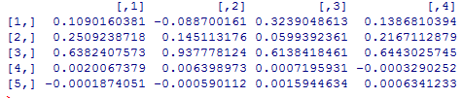

Index 16

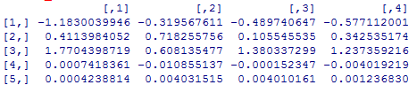

Index 26:

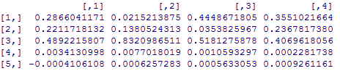

Index 36:

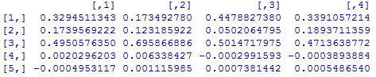

Index 29:

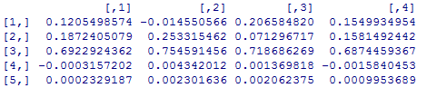

**R Code:**

betaclone = matrix(0,5,4)

FittedRet = matrix(0,NumMonths,1)

for (i in 1:4){

if(i==1){

submodel = lm((ChosenIdx[1:eps[1]]-FFactors[1:eps[1],6])~0+(as.matrix(FFactors[1:eps[1],2:5]- FFactors[1:eps[1],6])))

FittedRet[1:eps[1]] = submodel$fitted.values+ FFactors[1:eps[1],6]

}

if(i==2){

submodel = lm((ChosenIdx[(eps[1]+1):eps[2]]- FFactors[(eps[1]+1):eps[2],6])~0+(as.matrix(FFactors[(eps[1]+1):eps[2],2:5]- FFactors

[(eps[1]+1):eps[2],6])))

FittedRet[(eps[1]+1):eps[2]] = submodel$fitted.values+ FFactors[(eps[1]+1):eps[2],6]

}

if(i==3){

submodel = lm((ChosenIdx[(eps[2]+1):eps[3]]- FFactors[(eps[2]+1):eps[3],6])~0+(as.matrix(FFactors[(eps[2]+1):eps[3],2:5]-FFactors

[(eps[2]+1):eps[3],6])))

FittedRet[(eps[2]+1):eps[3]]=submodel$fitted.values+FFactors[(eps[2]+1):eps[3],6]

}

if(i==4){

submodel = lm((ChosenIdx[(eps[3]+1):NumMonths]-FFactors[(eps[3]+1):NumMonths,6])~0+(as.matrix(FFactors[(eps[3]+1):NumMonths,2:5]-

FFactors[(eps[3]+1):NumMonths,6])))

FittedRet[(eps[3]+1):NumMonths]=submodel$fitted.values+FFactors[(eps[3]+1):NumMonths,6]

}

betaclone[1:4,i]=coef(summary(submodel))[, 1][1:4]

betaclone[5,i]=1-sum(coef(summary(submodel))[, 1][1:4])

}

betaclone

**2. b~c**

|  |  |  |
| --- | --- | --- |
| Annualized Amount | Index 6 | Linear Clone of Index 6 |
| Mean | 0.08398058 | 0.07759704 |
| Volatility | 0.03557928 | 0.03577784 |
| Sharpe Ratio | 2.360379 | 2.168858 |

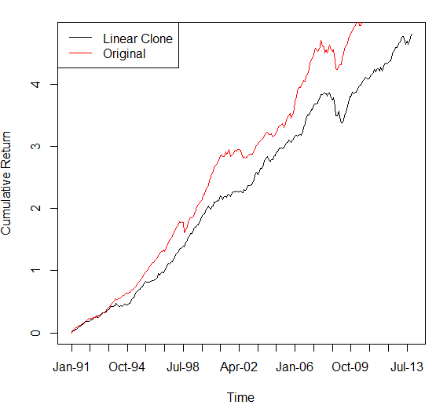

|  |  |  |
| --- | --- | --- |
| Annualized Amount | Index 16 | Linear Clone of Index 16 |
| Mean | -0.0276223 | -0.05437296 |
| Volatility | 0.1823409 | 0.1822462 |
| Sharpe Ratio | -0.1514871 | -0.298349 |

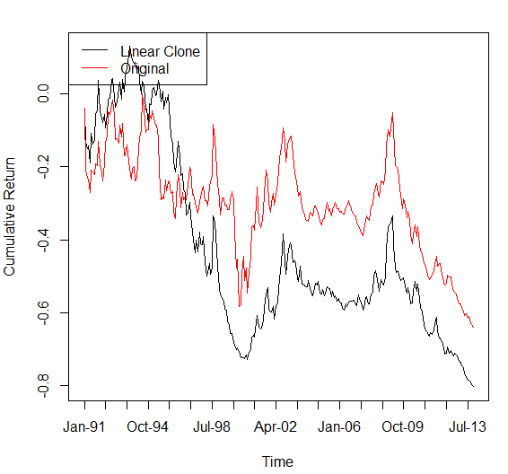

|  |  |  |
| --- | --- | --- |
| Annualized Amount | Index 26 | Linear Clone of Index 26 |
| Mean | 0.1145821 | 0.1219376 |
| Volatility | 0.06563792 | 0.06552957 |
| Sharpe Ratio | 1.74567 | 1.860803 |

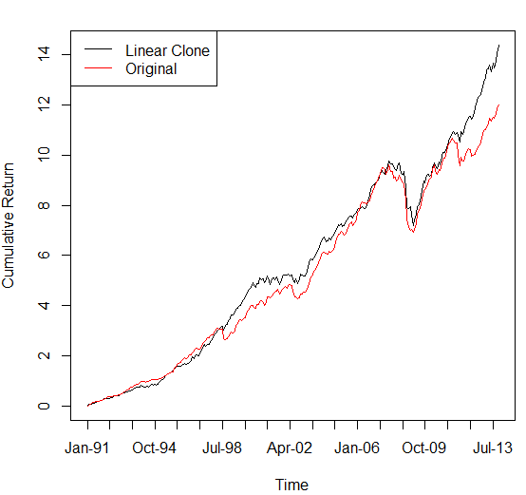

|  |  |  |
| --- | --- | --- |
| Annualized Amount | Index 36 | Linear Clone of Index 36 |
| Mean | 0.08088232 | 0.09151589 |
| Volatility | 0.06923958 | 0.06912386 |
| Sharpe Ratio | 1.168152 | 1.323941 |

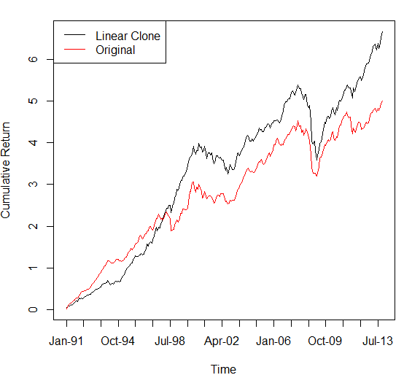

|  |  |  |
| --- | --- | --- |
| Annualized Amount | Index 29 | Linear Clone of Index 29 |
| Mean | 0.06481522 | 0.08229301 |
| Volatility | 0.05437826 | 0.05386179 |
| Sharpe Ratio | 1.191933 | 1.527855 |

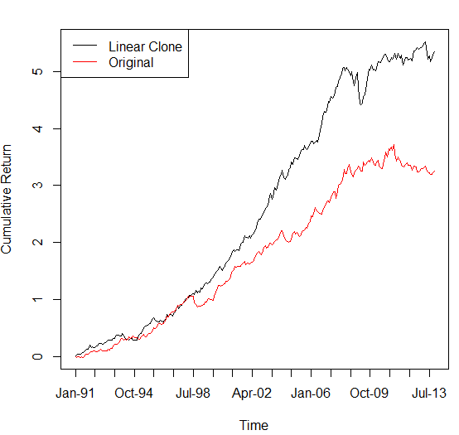

**R Code:**

gamma = sqrt((ChosenIdx-mean(ChosenIdx))^2/(FittedRet-mean(FittedRet))^2)

Rhat = matrix(0,NumMonths,1)

for (i in 1:NumMonths){

Rhat[i] = gamma[i]*FittedRet[i]

}

gamma = sqrt(sum((ChosenIdx-mean(ChosenIdx))^2)/sum((FittedRet-mean(FittedRet))^2))

Rhat = gamma*FittedRet

delta = 1-gamma

TBill = read.csv("TBill.csv",header=FALSE)

R_hat = Rhat + delta*TBill[,3]

# Annualized Amount

mean(ChosenIdx)*12

sd(ChosenIdx)*sqrt(12)

mean(ChosenIdx)/sd(ChosenIdx)*sqrt(12)

mean(R_hat)*12

sd(R_hat)*sqrt(12)

mean(R_hat)/sd(R_hat)*sqrt(12)

cumretOrig = matrix(0,NumMonths,1)

curetClon = matrix(0,NumMonths,1)

cumretOrig[1] = ChosenIdx[1]

curetClon[1] =R_hat[1]

for (i in 2:NumMonths) {

cumretOrig[i] = (1+cumretOrig[i-1])*(1+ChosenIdx[i])-1

curetClon[i] = (1+curetClon[i-1])*(1+R_hat[i])-1

}

plot(cumretOrig,ylim = c(-1,20),xlab = "Time", ylab = "Cumulative Return", xaxt = "n",col=1,type='l')

plot(curetClon,xlab = "Time", ylab = "Cumulative Return", xaxt = "n",col=1,type='l')

axis(1, at=seq(1,NumMonths,15), labels=FFactors[seq(1,NumMonths,15),1])

lines(cumretOrig,col = 2)

legend("topleft", legend=c("Linear Clone","Original"), col=1:2,lty=1,cex=1)